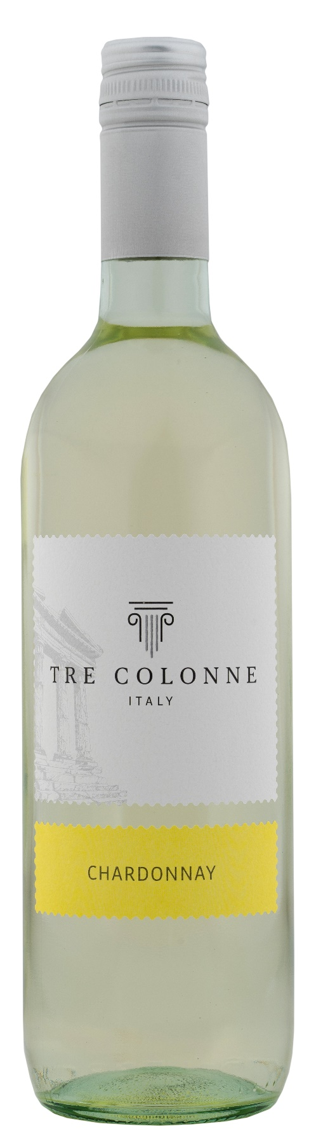
CHARDONNAY ITALIA – TRE COLONNE

Grape: Chardonnay 100%
Alc. Vol.%: 12
Vintage: 2025
Residual sugar g/l: 5,5
Total acidity g/l: 5,9
Region: Vineyards in northern Italy
Capacity: 750ml, 1500ml

CHARACTERISTICS

Vinification: Gentle pressing and cold maceration, afterwards fermentation at a controlled temperature of 18°C
Yield per ha: 16000kg
Colour: Light straw yellow
Bouquet: Ethereal and slightly fruity
Flavour: Pleasantly dry, soft and round

SERVING SUGGESTIONS

Excellent as an aperitif, with starters and fish dishes of all kinds.
Serving temperature 8-10°C
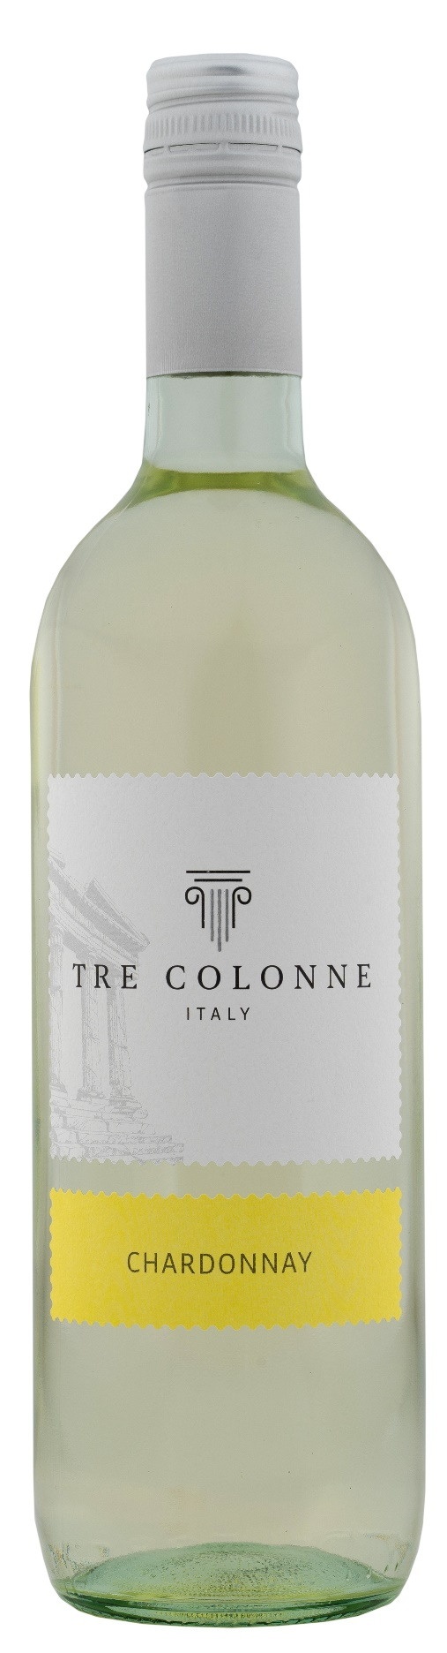
TECHNICAL INFORMATION/ PALETIZING

Size 750ml:
Article Nr. V14008A
GTIN-13 bottle 8017868005032
GTIN-13 carton 8017868005575
Closure Cork/Screwcap
Bottles/carton 6 bottles
Pallet size 80x120cm
Cartons/layer 25
Cartons/pallet 125
Kg/carton 7,2
Kg/pallet 925

Size 1500ml:
Article Nr. V14010B
GTIN-13 bottle 8017868005377
GTIN-13 carton 8017868005636
Closure Screwcap
Bottles/carton 6 bottles
Pallet size 80x120cm
Cartons/Layer 14
Cartons/pallet 56
Kg/carton 13,4
Kg/pallet 790

Contains sulphites
GVO Free
Revision 01. 14.05.2026

